Application Architecture - Personalized Networking Assistant
The application follows a three-tier architecture. The Streamlit frontend collects user input and sends requests to the FastAPI backend. The backend orchestrates AI modules including DistilBERT for event theme extraction, GPT-2 Small for conversation generation, and a Wikipedia fact-checking service. Outputs are combined into verified, personalized networking suggestions. A database layer can be used for storing users, sessions, generated starters, and logs.
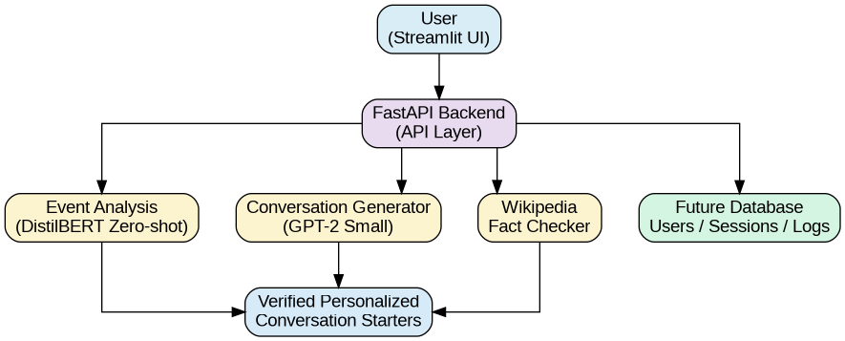

Architecture Flow
- User → Streamlit Frontend
- Frontend → FastAPI Backend
- Backend → DistilBERT Event Analysis
- Backend → GPT-2 Conversation Generator
- Backend → Wikipedia Fact Checking
- Backend stores/retrieves data from Database
- Combined verified response returned to the user

